DATA-SET ANALYSIS:

1.Types of books:

* Child books
* Youth Books
* Cook Books
* Do It books
* Reference books
* Art books
* Geology books
* ItalCook
* ItalAtlas
* Florence

2.Item Frequencies:

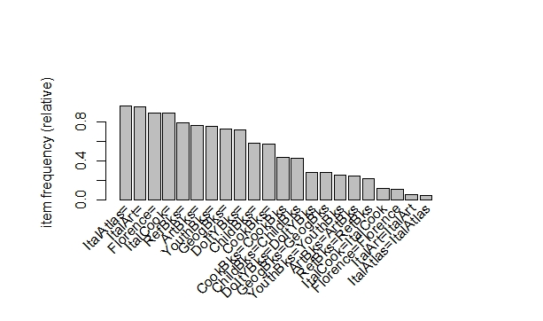

3. FOR SUPPORT =0.02 AND CONFIDENCE =0.5

lhs rhs support confidence lift

[1] {CookBks,DoItYBks,ArtBks,ItalCook} => {ItalArt} 0.0250 0.6849315 14.122299

[2] {CookBks,ArtBks,GeogBks,ItalCook} => {ItalArt} 0.0240 0.6666667 13.745704

[3] {ChildBks,CookBks,ArtBks,ItalCook} => {ItalArt} 0.0285 0.6263736 12.914920

[4] {CookBks,ArtBks,GeogBks,ItalArt} => {ItalCook} 0.0240 0.9600000 8.458150

[5] {ChildBks,CookBks,ArtBks,ItalArt} => {ItalCook} 0.0285 0.9500000 8.370044

[6] {CookBks,DoItYBks,ArtBks,ItalArt} => {ItalCook} 0.0250 0.9259259 8.157938

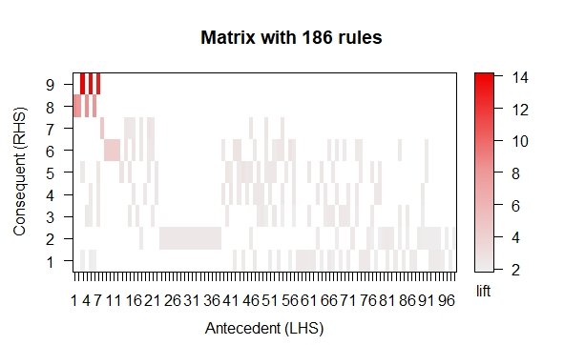

4.FOR SUPPORT =0.04 AND CONFIDENCE=0.6

lhs rhs support confidence lift

[1] {ChildBks,YouthBks,CookBks,ArtBks} => {GeogBks} 0.0465 0.6940299 2.514601

[2] {ChildBks,CookBks,DoItYBks,GeogBks} => {ArtBks} 0.0535 0.6011236 2.494289

[3] {ChildBks,CookBks,RefBks,ArtBks} => {GeogBks} 0.0405 0.6639344 2.405560

[4] {ChildBks,CookBks,DoItYBks,ArtBks} => {GeogBks} 0.0535 0.6524390 2.363910

[5] {ChildBks,YouthBks,CookBks,ArtBks} => {DoItYBks} 0.0445 0.6641791 2.355245

[6] {ChildBks,YouthBks,CookBks,RefBks} => {GeogBks} 0.0440 0.6470588 2.344416

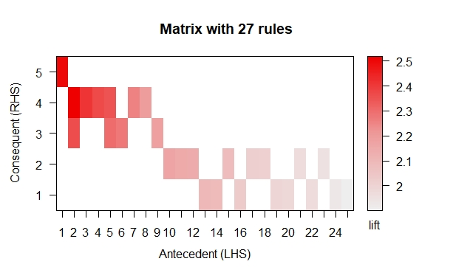

5.FOR SUPPORT =0.04 AND CONFIDENCE=0.3

lhs rhs support confidence lift

[1] {ChildBks,CookBks,DoItYBks,GeogBks} => {ArtBks} 0.0535 0.6011236 2.494289

[2] {ChildBks,CookBks,DoItYBks,ArtBks} => {GeogBks} 0.0535 0.6524390 2.363910

[3] {ChildBks,CookBks,DoItYBks,GeogBks} => {YouthBks} 0.0510 0.5730337 2.315288

[4] {ChildBks,CookBks,ArtBks,GeogBks} => {DoItYBks} 0.0535 0.6407186 2.272052

[5] {ChildBks,YouthBks,CookBks,DoItYBks} => {GeogBks} 0.0510 0.6219512 2.253446

[6] {ChildBks,YouthBks,CookBks,GeogBks} => {DoItYBks} 0.0510 0.6144578 2.17892

